Anotaciones

Almacenar valores al rotar
@Override
protected void onSaveInstanceState(Bundle outState) {
super.onSaveInstanceState(outState);
outState.putString("num1", editText1.getText().toString());
outState.putString("num2", editText2.getText().toString());
}

@Override
protected void onRestoreInstanceState(Bundle savedInstanceState) {
super.onRestoreInstanceState(savedInstanceState);
if (savedInstanceState != null) {
String num1 = savedInstanceState.getString("num1");
String num2 = savedInstanceState.getString("num2");
editText1.setText(num1);
editText2.setText(num2);
}
}

PONER ICONO A LA APLICACIÓN
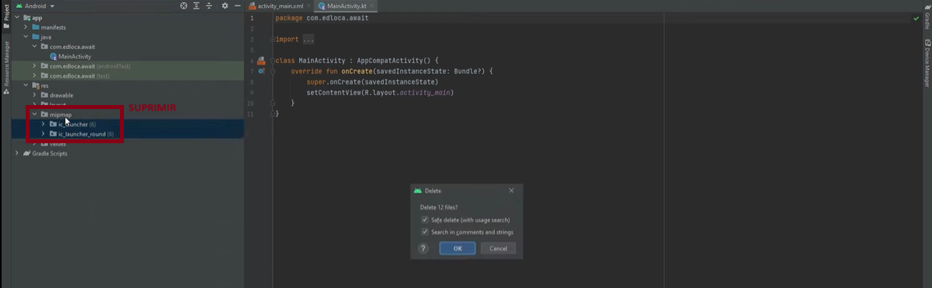
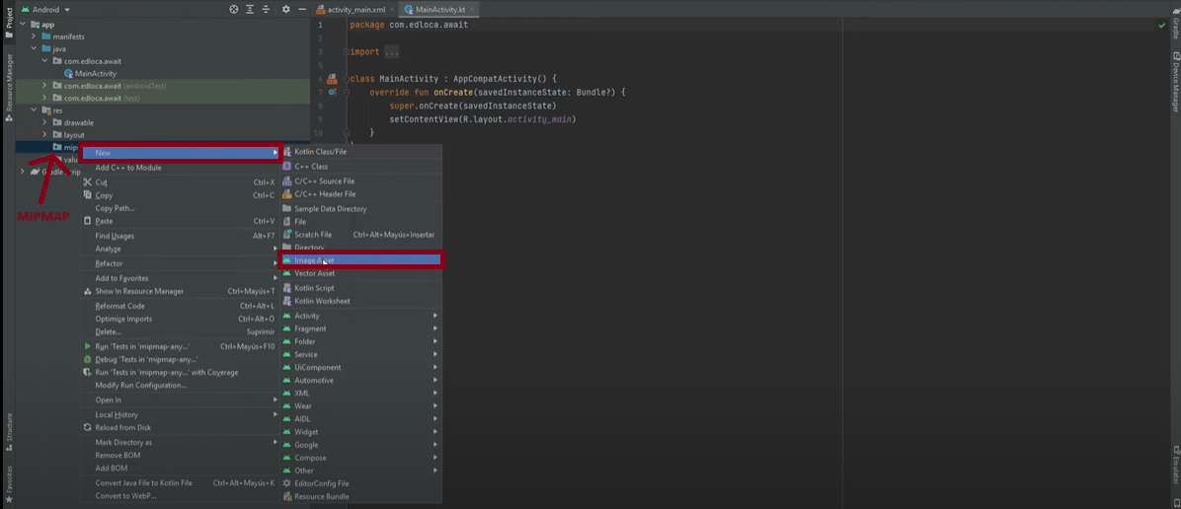
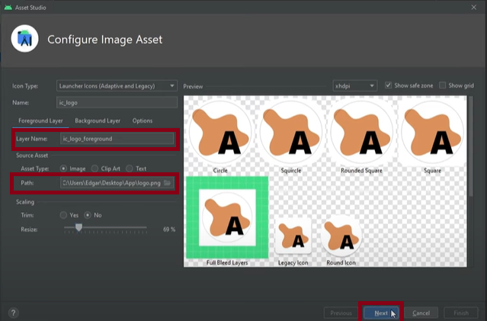
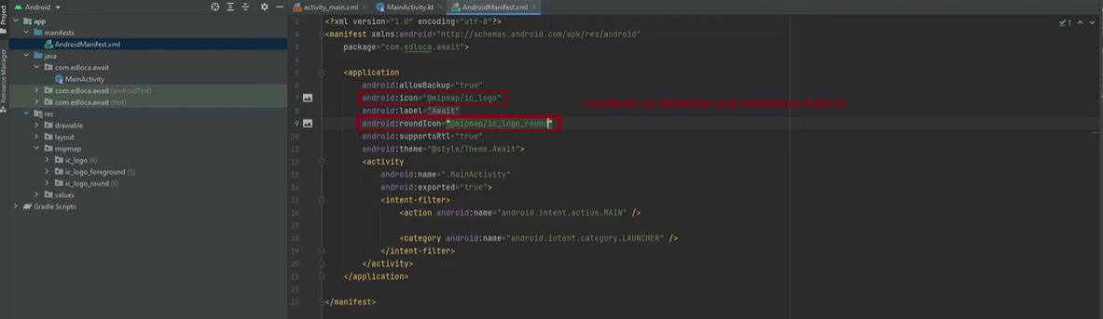

dddd

